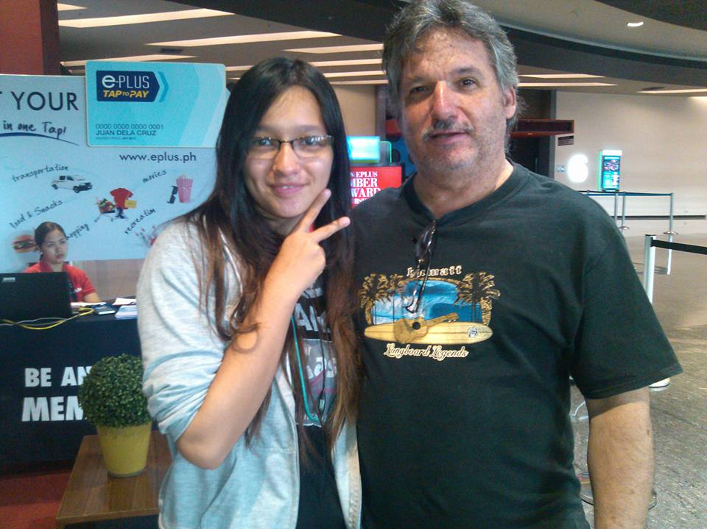

**Duane “DD” Donaldson**

A middle-aged student taking up Bachelor of Computer Science at Saint Louis University, Baguio, Benguet, Philippines. I love all things mechanical and electronic. I started my career at 17 repairing appliances from bicycles to televisions. Educated in electronics by way of the Sears Extension Institute and Cleveland Institute of Electronics earning two degrees and a half dozen certifications. Small engine and other mechanical training attained via an apprenticeship while employed at Sears.

At the age of 19 I joined the US Air Force as an Airlift and Bombardier Aircraft Maintenance Technician attaining the rank of Master Sergeant and a 7 skill level, Master Craftsman, primarily on the C-130E/H Hercules turboprop cargo aircraft. Over the next 21 years of encompassing the globe, I earned two degrees in Aeronautical / Mechanical Engineering and more than 40 certifications. While serving in the military, I started working as an automotive mechanic as a second job, eventually stating my own businesses and earned nine ASE certifications including the L1 Master Technician while living and working several different jobs in Tokyo Japan.

I am the father of 5, grandfather of three thanks to my eldest daughter where they live in Tacloban, Leyte with her Philippine Army husband. My second son has two degrees from Holy Angel University, Angeles City, Pampanga, he is currently a CS / IT instructor at a local High School. My third son is currently a student of Bachelor of Computer Science at the University of Arkansas, Conway, AR, USA. My fourth (pic above) and fifth daughters are in high school and primary school and are destined to be a computer scientist and an electronics engineer.

My passion is automotive computer diagnostics by utilizing a Scanner and an Oscilloscope. I will be using my newly acquired education to design and develop electronic gadgets and software to use in tandem with the oscilloscope to make this difficult computer diagnostic task much easier as I am always looking to the future. Currently looking to acquire a new wife to have a couple more kids with and expand the limits of human possibilities.

The greater our knowledge increases the more our ignorance unfolds.

John F. Kennedy

https://www.brainyquote.com/slideshow/authors/top_10_john_f_kennedy_quotes.html